**Financial Statistic Systems**

**Insights and Strategies**

**Dashboard I: Income Sources**

**Insights and Recommendations:**

Income Achievement: There was a notable improvement, with the company achieving 86% of its target in 2023 compared to 80% in 2022.

Revenue Growth: Subscription services saw one of the most substantial increases, contributing a 40% growth year over year. This indicates strong customer retention or acquisition, particularly as the company seems to have focused more on B2C services. Both Premium and Prime subscriptions contributed significantly to the overall income from subscriptions, demonstrating that the company’s focus on tiered pricing strategies and offering differentiated services has paid off. Together, they indicate a rise in customer willingness to spend more for value-added services.

While the overall advertising income didn’t change significantly, it is clear that Facebook, Youtube, and Google Ads are the main platforms being used. Given the stagnation in these categories, the company could experiment with new ad formats, explore emerging platforms, or increase investment in more modern advertising channels.

While licensing is a stable and significant income source, it is not contributing to growth, meaning that the company may need to explore innovations, marketing strategies, or partnerships to unlock further potential from licensing revenues.

The lack of growth in renting subcategories suggests that this income source has matured. The company may need to rethink its strategy if it wants to stimulate growth in the renting category, perhaps by diversifying the types of equipment, lands, or offices available for rent.

The low number of assets sold, combined with the flat income, suggests that asset sales might not be a primary focus for the company. This is either a strategic decision or a reflection of limited market demand for assets. If the company intends to grow this category, it could explore new assets to sell or develop a better asset sales pipeline.

Profitability: Operating profits grew from 144,177 to 154,650.

Market Focus: The shift from B2B to B2C indicates a strategic pivot toward consumer-focused income.

**Dashboard II: Geographical**

There was a 39.7% decline in total revenue in from 2022 to 2023. This indicates a significant reduction in sales across all or most regions, signaling a challenging year for the company.

USA dropped sharply from the leading position in 2022 ($387,584) to $127,904 in 2023, now contributing only 15.47% of the company’s total revenue.

Russia saw a 16.5% growth in sales, becoming the top-performing market in 2023, with the largest revenue contribution at 26.53% of total sales.

Egypt's sales also declined but not as sharply, maintaining its second position in both years. However, the 11.5% decrease in revenue from $365,892 to $204,528 indicates challenges in the Egyptian market.

United Kingdom improved its ranking, growing from $178,572 in 2022 to $129,304 in 2023, though it still recorded a decline.

Overall, the company faced a challenging year in 2023 with significant revenue drops in most regions, except for Russia. Despite the overall downturn, the company managed to achieve a higher percentage of its sales target, showing operational resilience.

**Recommendations:**

**Key Markets**: Russia and Egypt are the key revenue drivers in 2023, but the USA’s sharp decline is a concern. The company may need to investigate the reasons for this dramatic drop in the USA and explore recovery strategies.

**Market Diversification**: While Russia and Egypt are still strong performers, the company might want to focus on improving sales in the USA and finding growth in other regions, such as the United Kingdom, to offset any regional risks.

**Tax Impact**: Although the company's total taxes have decreased due to lower revenue, they remain proportional. The company should continue monitoring tax compliance while seeking ways to optimize taxation strategies as it recovers revenue.

**Dashboard III: Sales Process**

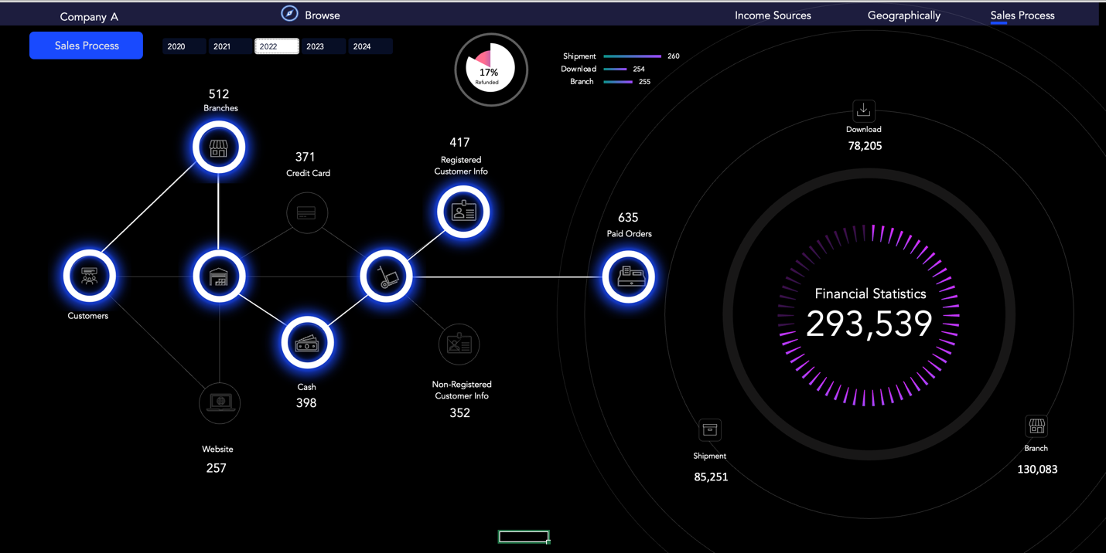

The company experienced a 38% decline in sales revenue from 2022 to 2023. This is a significant drop, which might indicate challenges in customer acquisition, decreased demand, or operational issues in 2023. Branches continue to be a stronger sales channel, even after significant reductions in 2023, likely because customers value the in-person experience, prefer cash payments, or trust physical stores more than the website. The closure of branches or downsizing might be a response to cost-cutting measures, a change in strategy, or operational challenges. Despite a 43% reduction in branches in 2023, the branches still outperformed the website in terms of sales. This highlights that while the company reduced its physical footprint, it didn’t adequately capture these customers in the online space.

The website did not effectively compensate for the loss of branches, as shown by the relatively small number of online orders.

The company may benefit from focusing on a hybrid approach by maintaining key branches in high-performing regions while also heavily investing in digital transformation to encourage customers to shop online. This could include:

* Improved website design for better user experience.
* Promotions and incentives for online shopping (e.g., discounts for first-time online customers).
* Expanding payment options to include methods that make it easier for branch customers to transition to online purchases.

Shift in Customer Base: Both registered and non-registered customers declined, but the drop in non-registered customers was more severe. This highlights the importance of re-engaging with new or one-time customers and converting them into registered, loyal customers.

Refund issues: The refund rate nearly doubled from 2022 to 2023, which is a significant red flag. A high refund rate indicates issues in product quality, customer satisfaction (late deliveries, incorrect orders, or poor customer service), or mismatch between customer expectations and the products/services delivered. The closure of branches in 2023 may have caused customer service issues. In-person support and customer service, which could have resolved issues before refunds were requested, may have been reduced due to fewer physical locations.

**Recommendations to Address Refund Issues:**

1. Identify the Root Cause
2. Improve Product Quality
3. Enhance Customer Support
4. Address Operational Inefficiencies
5. Customer Education
6. Leverage Digital Feedback